**TVD basics**

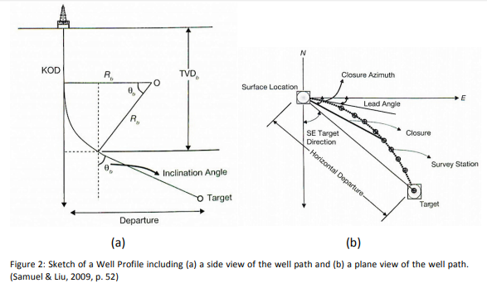

**Averaging Method** as per formula below:

[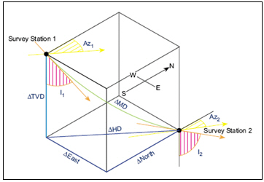](http://www.drillingformulas.com/angle-averaging-method-in-directional-drilling-calculation/directional-survey-photo/)

[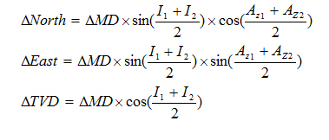](http://www.drillingformulas.com/angle-averaging-method-in-directional-drilling-calculation/angle-averaging-method/)

Where;

MD = measured depth between surveys in ft

I1 = inclination (angle) at upper survey in degrees

I2 = inclination (angle) at lower in degrees

Az1= Azimuth direction at upper survey

Az2 = Azimuth direction at lower survey

**Calculation example for Angle Averaging Method**

**Survey 1**

Depth = 7500 ft

Inclination = 45 degree

Azimuth = 130degree

**Survey 2**

Depth = 7595 ft

Inclination = 52 degree

Azimuth = 139 degree

[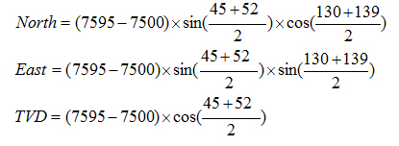](http://www.drillingformulas.com/angle-averaging-method-in-directional-drilling-calculation/angle-averaging-method-number/)

As per formula above,

North = -49.87 ft

East = 50.74 ft

TVD = 62.95 ft

Dogleg Dogleg is a term that refers to the amount of curvature in the well path. Usually it calculated between two survey stations and quantified as degrees per unit of distance called Dogleg Severity (DLS).

Dogleg achieved depends on formation parameters such as dip angle, strike, hole inclination, gauge of hole, bit type and length, weight on bit and bottom hole assembly.

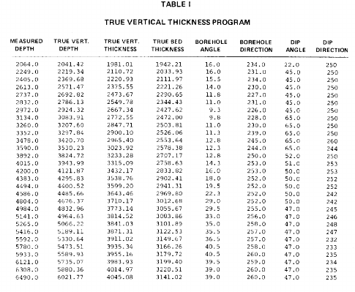

<https://gsajournals.org/articles/000/000/000000468-true-vertical-depth-true-vertical-thickness-and-true-stratigraphic-thickness-logs.php>

The True Vertical Depth (TVD) of the well depending on

* the drilling technique used
* and the geological formations that encountered during the drilling process,

